

Product Catalog
2025

DOC000413 Rev.K

Applied Spectral Imaging (ASI) is a global leader in biomedical imaging with a comprehensive product portfolio and a global distribution footprint.

Founded in 1993, ASI markets, services, and supports its products in over 80 countries worldwide. With a broad FDA clearance portfolio, customers can rest assured that ASI applications have been rigorously tested for compliance and clinical use.

The Company's technology, powered by GenASIs, offers an extensive portfolio of dedicated solutions for brightfield, fluorescence and spectral imaging analysis, including HiPath Pro, PathFusion, HiBand, HiFISH and CytoPower which address diagnostic needs across multiple domains, including karyotyping, FISH, and digital pathology.
The Company has offices in the US and a global network of distribution partners.

We will be delighted to collaborate with you!
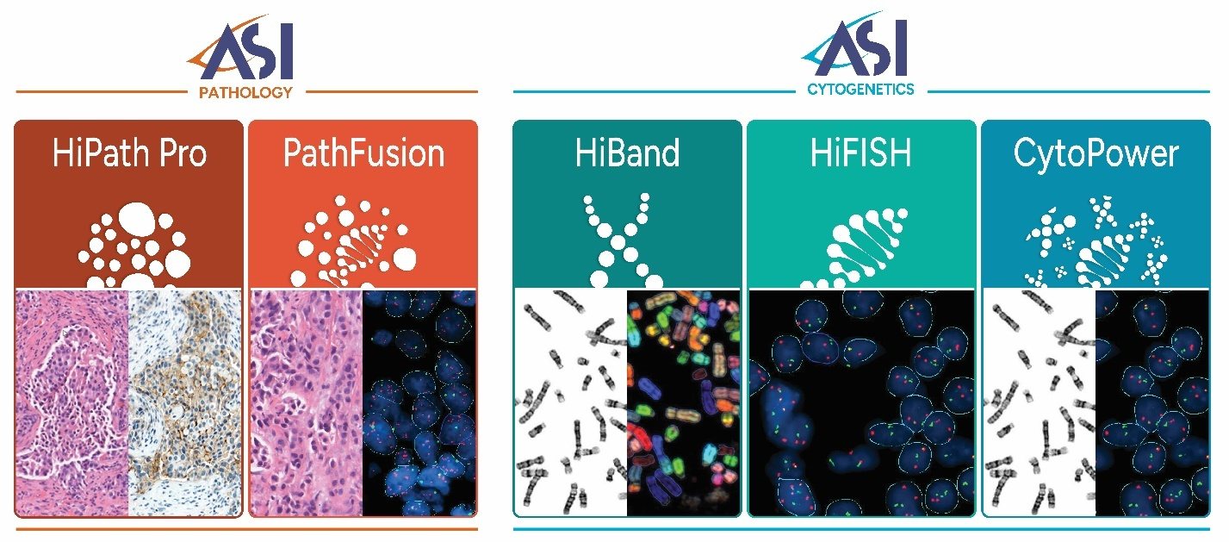
DOC000413 Rev. I

Although the information in this Product Catalog is presented in good faith, ASI makes no representations or warranties as to the completeness or accuracy of the information and has no liability for any errors or omissions contained in this Product Catalog or accompanying materials. In no event will ASI be responsible for damage of any nature whatsoever resulting from the use of or reliance upon information from this Product Catalog or the products to which the information refers.
This Product Catalog and its contents, including any product configuration or information, is considered ASI's confidential information and shall not be disclosed to third parties.
This disclaimer does not affect in any manner ASI’s standard terms of sale.
Prices and Product Specifications
ASI reserves the right to correct, change, delete or otherwise modify the information in this Product Catalog from time to time, including pricing, in its sole discretion, without prior notice.
ASI also uses reasonable efforts to carefully define its product specifications; however, ASI may amend such product specifications from time to time as it deems necessary. You hereby acknowledge and agree that ASI will not be liable in any manner for any modification of its pricing or product specifications.
All pictures are provided for illustration purposes only. Some variations between picture and product may occur. Illustrations are provided to display ASI's product(s) and may include items not necessarily included with the products. Some products listed may be non-stock items.
Microscopes
ASI systems support most microscope models for manual capture. ASI automated systems (9-slide scanner and 99+ Tray Loader) support the following microscope models: Olympus BX61, Olympus BX63 and Zeiss AxioImager Z2.
For Microscope quotes please contact sales@spectral-imaging.com
Orders
Partners may place orders for the goods and services represented in this Product Catalog by issuing to ASI a valid purchase order referencing a valid ASI quotation that is still in effect. No purchase order will become binding on ASI unless and until accepted by ASI in writing.
Shipping
In general, unless otherwise agreed with Partner, product pricing reflects DAP (Incoterms 2020). Airfreight, insurance, shipping and any special packaging will be charged separately and included in the relevant quotation and invoice.
Tax
The partner will be responsible for and pay all applicable taxes, customs, and duties, including sales, value added, excise and other similar taxes and/or charges that may apply to the purchase of products from ASI.
Contact
To receive a quote, please contact sales@spectral-imaging.com



HiBand
Computer-Aided
Chromosome Analysis and
Karyotyping Solution

HiBand Manual System CPQBNS09-M

High-resolution chromosome capture and analysis on a manual microscope setup with automated computer-aided karyotyping option.

HiBand Manual System | Top Highlights

Manual metaphase capture using 5MP CMOS camera with 22mm FOV

Suggested karyogram ready when opening a metaphase for analysis

Single "Magic Tool" for all karyogram corrections

Auto enhancement, banding, ISCN, and overlap scoring

Custom reports with clone summary and common aberrations
GenASIs 8.4.1 software inclusive  of the following licenses:  - Case Data Manager™ software license for data management, viewing, and archiving inclusive of network connectivity of multiple systems  - BandView™ Software License for chromosome analysis and karyotyping inclusive of image acquisition module | Capture & Analysis Platform  5MP CMOS Monochrome Camera  - 2/3" high resolution monochrome digital CMOS  - Resolution 2448 px X 2048 px  - Pixel size 3.45 µm x 3.45 µm  - Pixel depth 12 bit  - Interface USB3  Computer  - Tower Form  - Processor Intel Core i7-13700K  - Memory 16GB RAM  - Hard Drive 512GB SSD  - Operating system Microsoft Windows 11 or 10 64 Bit  Professional or Enterprise edition
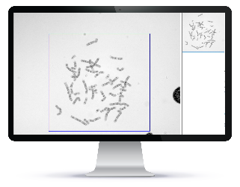
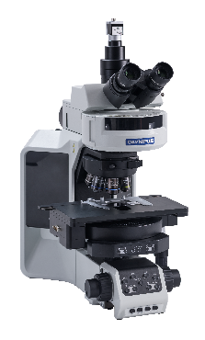

Product Options
Catalog # | Product Name

Software
FPRSF0155 | Aided Karyotyping™ software license, for automatic chromosome segmentation and classification  Note: Display card NVIDIA RTX-4060 8 GB is required
FPRSF0136 | LabLife™ software license for measurement, management, and reporting of the lab performance statistics
FPRSF0111 | Multispecies™ software license for research and karyotyping of non-human (other species) samples
FPRSF0107 | FISHView™ software license for Fluorescent Karyotyping, Image Enhancement and Documentation, Inclusive of mCounter and Image Acquisition Module
FPRSF0119 | MetScan™ Gallery software license for review and selection of acquired metaphases

Accessories
FPRAC0135 | Monitor 27" resolution 2560X1440 (16:9)
FPRAC0092 | Handheld barcode reader  Zebra Technologies (1D Code 128 & 2D QR code)

Microscope Accessories
FPRAC0137 | C-Mount 0.5X

HiBand Scanning System CPQBNS09-S

High-throughput automated metaphase scanning with integrated computer-aided chromosome detection and karyotyping.

HiBand Scanning System | Top Highlights

Metaphase scan at 10x with high-res capture at 100x

Suggested karyograms prepared during scanning and ready for immediate review

Mitotic Index measured per slide

Auto enhancement, banding, ISCN, and overlap scoring

Homolog comparison within/between cases

GenASIs 8.4.1 software inclusive  of the following licenses:  - Case Data Manager™ software license for data management, viewing, and archiving inclusive of network connectivity of multiple systems  - MetScan™ software license for scanning and detection of metaphases, including automated image acquisition of metaphases | Scan & Analysis Platform  5MP CMOS Monochrome Camera  - 2/3" high resolution monochrome digital CMOS  - Resolution 2448 px X 2048 px  - Pixel size 3.45 µm x 3.45 µm  - Pixel depth 12 bit  - Interface USB3  Motorized Scanning Stage  - Tray for 9 slides capacity  - Joystick 2 axis, 4 fast function buttons  - ASI Controller  Computer  - Tower Form Series PC  - Processor Intel Core i7-13700K  - Display card NVIDIA RTX-4060 8 GB  - Memory 16GB RAM  - Hard Drive 512GB SSD  - Operating system Microsoft Windows 11 or 10 64 Bit  Professional or Enterprise edition
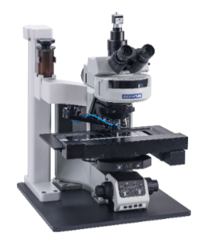
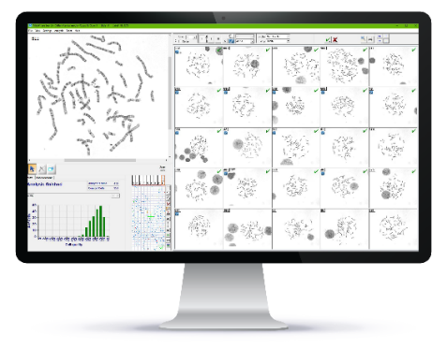

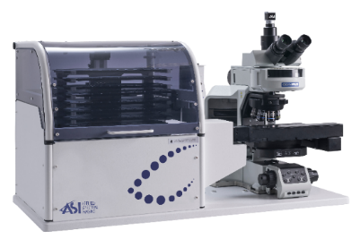

Product Options
Catalog # | Product Name

Software
FPRSF0155 | Aided Karyotyping™ software license, for automatic chromosome segmentation and classification
FPRSF0136 | LabLife™ software license for measurement, management, and reporting of the lab performance statistics
FPRSF0121 | MNScore™ software license for scanning and scoring of Cytokinesis-blocked micronucleus
FPRSF0111 | Multispecies™ software license for research and karyotyping of non-human (other species) samples
FPRSF0109 | BandView™ software license for chromosome analysis and karyotyping inclusive of image acquisition module
FPRSF0107 | FISHView™ software license Fluorescent Karyotyping, Image Enhancement and Documentation, Inclusive of mCounter and Image Acquisition Module

Tray Loader
FPRAC0127 | Tray Loader™ (1D) for 99+ slides capacity inclusive of  11 slide trays  Barcode printer, labels (5 rolls) and ribbons (2)  1D barcode reader  Automated oil dispenser
FPRAC0128 | Tray Loader™ (2D) for 99+ slides capacity inclusive of  11 slide trays  Barcode printer, labels (5 rolls) and ribbons (2)  2D barcode reader  Automated oil dispenser

Accessories
FPRAC0054 | Automated oil dispenser for 9-slides scanner  Peristaltic oil pump  Reservoir of 150 ml
FPRAC0135 | Monitor 27" resolution 2560X1440 (16:9)
FPRAC0155 | Barcode printer Zebra Technologies ZD621T (Customized to ASI products)
FPRAC0092 | Handheld barcode reader  Zebra Technologies (1D Code 128 & 2D QR code)

Microscope Accessories
FPRAC00137 | C-Mount 0.5X

HiBand Review System CPQBNS09-R

Dedicated workstation for analyzing, reviewing and signing out cytogenetic cases.

HiBand Review System | Top Highlights

Suggested karyograms ready for immediate review

Single "Magic Tool" for all karyogram corrections

Auto enhancement, banding, ISCN, and overlap scoring

Homolog comparison within/between cases

Custom reports with clone summary and common aberrations

GenASIs 8.4.1 software inclusive  of the following licenses:  - Case Data Manager™ software license for data management, viewing, and archiving inclusive of network connectivity of multiple systems  - BandView™ software license for chromosome analysis and karyotyping | Review & Analysis Platform  Computer  - Processor Intel Core i7-13700K  - Memory 16GB RAM  - Hard Drive 512GB SSD  - Operating system Microsoft  Windows 11 or 10 64 Bit  Professional or Enterprise edition
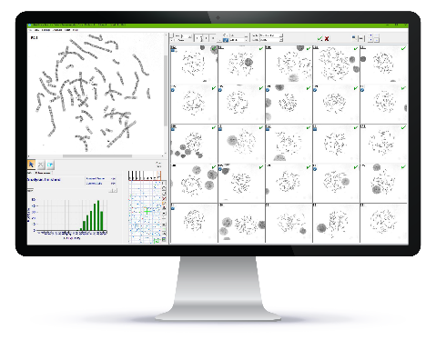
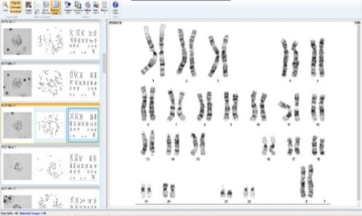

Product Options
Catalog # | Product Name

Software
FPRSF0155 | Aided Karyotyping™ software license, for automatic chromosome segmentation and classification  Note: Display card NVIDIA RTX-4060 8GB is required depending on workflow
FPRSF0136 | LabLife™ software license for measurement, management, and reporting of the lab performance statistics
FPRSF0111 | Multispecies™ software license for research and karyotyping of non-human (other species) samples
FPRSF0108 | FISHView™ software license for fluorescent karyotyping, image enhancement and documentation
FPRSF0119 | MetScan™ Gallery software license for review and selection of acquired metaphases
FPRSF0113 | HiSKY™ software License for review and spectral karyotyping
FPRSF0122 | MNScore™ software license for review of scored Cytokinesis-blocked micronucleus

Accessories
FPRAC0135 | Monitor 27" resolution 2560X1440 (16:9)
FPRAC0092 | Handheld barcode reader  Zebra Technologies (1D Code 128 & 2D QR code)

HiBand ScanLink Cyto System CPQBNS003

Third-party image import with computer-aided chromosome detection and digital karyotyping.

HiBand ScanLink Cyto System | Top Highlights

Suggested karyograms prepared on metaphase images acquired on third-party scanner

Single "Magic Tool" for all karyogram corrections

Auto enhancement, banding, ISCN, and overlap scoring

Homolog comparison within/between cases

Custom reports with clone summary and common aberrations

GenASIs 8.4.1 software inclusive  of the following licenses:  - Case Data Manager™ software license for data management, viewing, and archiving inclusive of network connectivity of multiple systems  - ScanLink Cyto™ software license | ScanLink Cyto Platform  Computer  - Processor Intel Core i7-12500  - Memory 16GB RAM  - Display card NVIDIA RTX-4060 8 GB  - Hard Drive 512GB SSD  - Operating system Microsoft  - Windows 11 or 10 64 Bit  - Professional or Enterprise edition
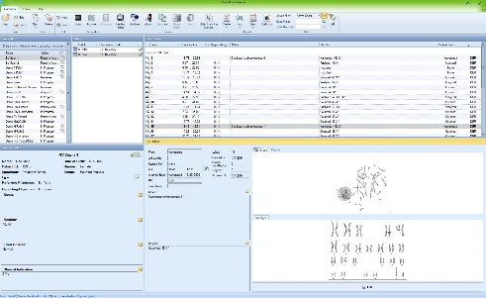

Product Options
Catalog # | Product Name

Software
FPRSF0109 | BandView™ software license for chromosome analysis and karyotyping inclusive of image acquisition module

Accessories
FPRAC0135 | Monitor 27" resolution 2560X1440 (16:9)

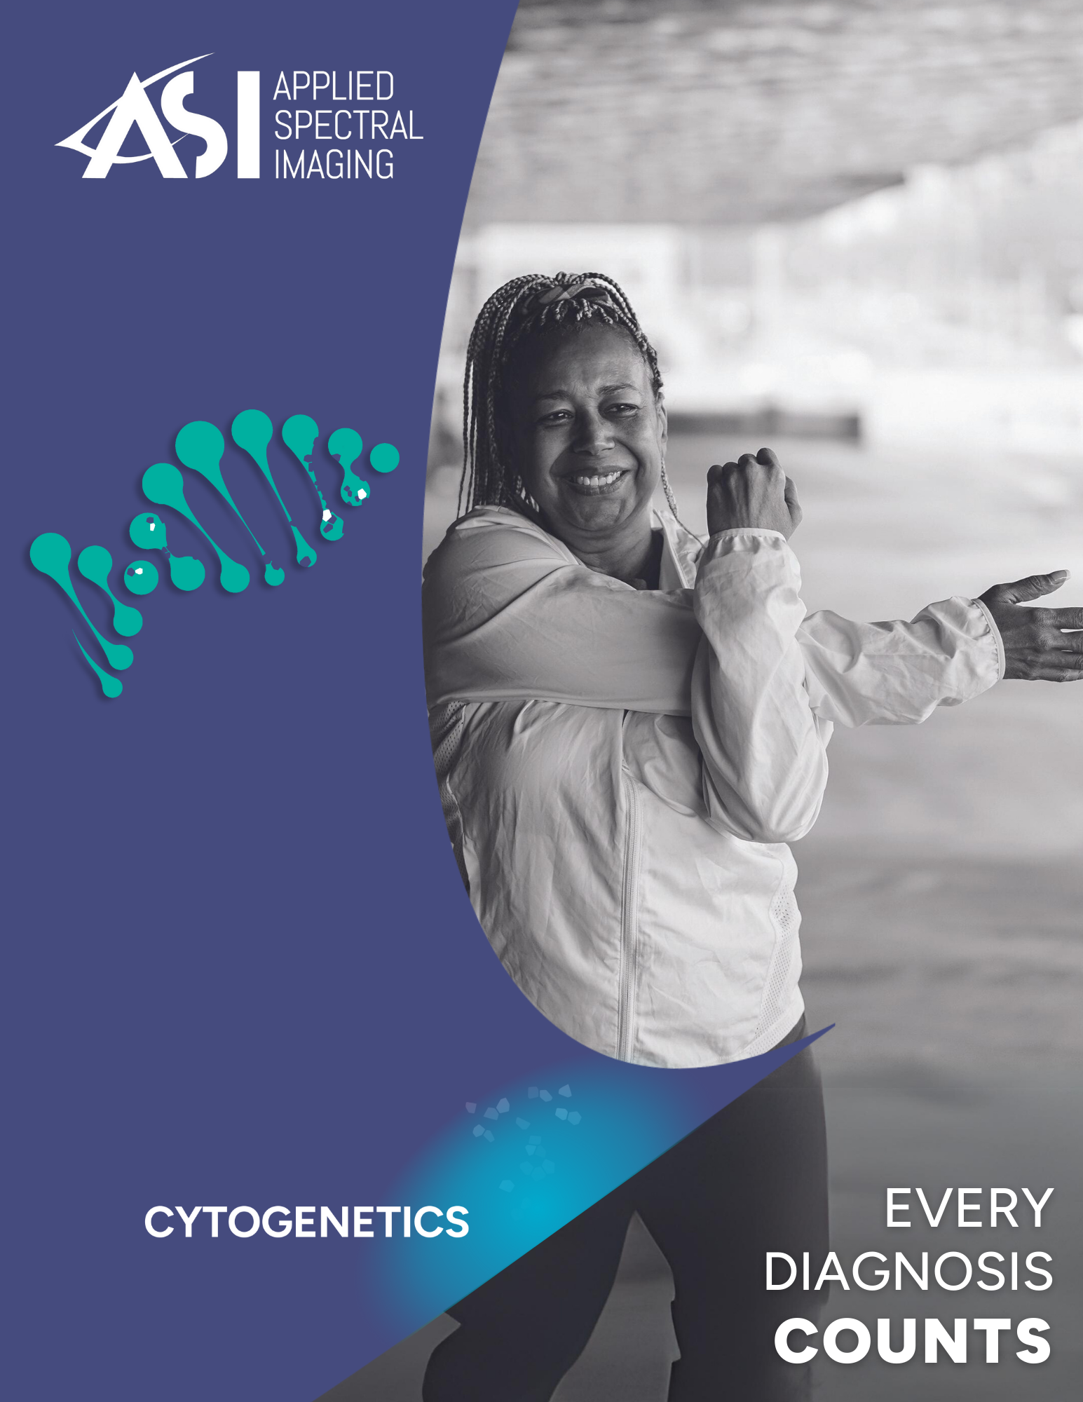

HiFISH
Digital FISH Analysis

HiFISH Manual System CPQBNS05-M
Probe vendor-agnostic FISH analysis on images captured on a manual microscope setup.

HiFISH Manual System | Top Highlights

- Z-stack FISH imaging in high resolution - even on manual microscopes
- Vendor-agnostic FISH probe support across sample types
- Auto exposure and contrast adjustment
- Integrated karyotyping with quantitative signal analysis
- mCounter tool for fast double-blinded scoring

GenASIs 8.4.1 software inclusive  of the following licenses:  - Case Data Manager™ software license for data management, viewing, and archiving inclusive of network connectivity of multiple systems  - FISHView™ software license for Fluorescent Karyotyping, Image Enhancement and Documentation, Inclusive of mCounter and Image Acquisition Module | Capture & Analysis Platform  5MP CMOS Monochrome Camera  - 2/3" high resolution monochrome digital CMOS  - Resolution 2448 px X 2048 px  - Pixel size 3.45 µm x 3.45 µm  - Pixel depth 12 bit  - Interface USB3  Computer  - Tower Form  - Processor Intel Core i7-13700K  - Memory 16GB RAM  - Hard Drive 512GB SSD  - Microsoft Windows 11 or 10 64 Bit Professional or Enterprise edition
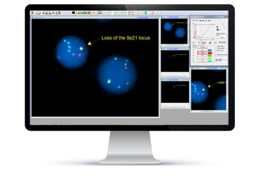
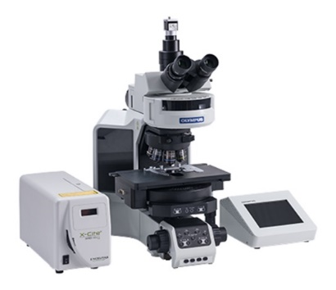

Product Options
Catalog # | Product Name

Software
FPRSF0136 | LabLife™ software license for measurement, management, and reporting of the lab performance statistics
FPRSF0138 | TissueSuite™ FISH software license for on-screen Matching of tissue FISH with External H&E Image
FPRSF0117 | SpotScan™ software license for scanning and image acquisition inclusive of FISH review and analysis for all sample types both cell suspension and tissue
FPRSF0114 | SpotScan™ software license for FISH review and analysis for all sample types both cell suspension and tissue FISH
FPRSF0111 | Multispecies™ software license for research and karyotyping of non-human (other species) samples

Accessories
FPRAC0135 | Monitor 27" resolution 2560X1440 (16:9)
FPRAC0092 | Handheld barcode reader  Zebra Technologies (1D Code 128 & 2D QR code)
FPRAC0147 | Programmed 24 Key USB Keypad

Microscope Accessories
FPRAC0137 | C-Mount 0.5X

HiFISH Scanning System CPQBNS05-S
Automated digital FISH scanning and analysis solution with real-time FISH signal detection, optimized per
hybridization.

HiFISH Scanning System | Top Highlights

- Automated FISH scanning with multi-color layers and Z-stack
- Automatic cell segmentation, signal detection and cell classification
- Vendor-agnostic FISH probe support across sample types
- Blinded analysis with single or multi-reader options and supervisor review
- Optimized contrast for enhanced signal clarity and faster workflow

GenASIs 8.4.1 software inclusive  of the following licenses:  - Case Data Manager™ software license for data management, viewing, and archiving inclusive of network connectivity of multiple systems  - SpotScan™ software license for scanning and image acquisition inclusive of FISH review and analysis for all sample types both cell suspension and tissue  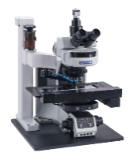  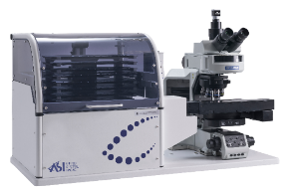  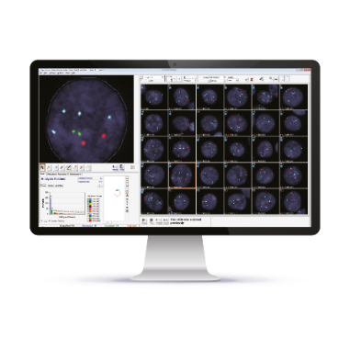 | Scan & Analysis Platform  5MP CMOS Monochrome Camera  - 2/3" high resolution monochrome digital CMOS  - Resolution 2448 px X 2048 px  - Pixel size 3.45 µm x 3.45 µm  - Pixel depth 12 bit  - Interface USB3  Motorized Scanning Stage  - Tray for 9 slides capacity  - Joystick 2 axis, 4 fast function buttons  - ASI Controller  Computer  - Tower Form Series PC  - Processor Intel Core i7-13700K  - Display card NVIDIA RTX-4060 8 GB  - Memory 16GB RAM  - Hard Drive 512GB SSD  - Operating System Microsoft Windows 11 or 10 64 Bit  Professional or Enterprise edition

Product Options
Catalog # | Product Name

Software
FPRSF0136 | LabLife™ software license for measurement, management, and reporting of the lab performance statistics
FPRSF0143 | FISHView™ software license for Fluorescent Karyotyping, Image Enhancement and Documentation,  Inclusive of mCounter and Image Acquisition Module
FPRSF0138 | TissueSuite™ FISH software license for on-screen Matching of tissue FISH with External H&E Image
FPRSF0111 | Multispecies™ software license for research and karyotyping of non-human (other species) samples

Tray Loader
FPRAC0127 | Tray Loader™ (1D) for 99+ slides capacity inclusive of  11 slide trays  Barcode printer, labels (5 rolls) and ribbons (2)  1D barcode reader  Automated oil dispenser
FPRAC0128 | Tray Loader™ (2D) for 99+ slides capacity inclusive of  11 slide trays  Barcode printer, labels (5 rolls) and ribbons (2)  2D barcode reader  Automated oil dispenser

Accessories
FPRAC0054 | Automated oil dispenser for 9-slide Scanner  Peristaltic oil pump  Reservoir of 150 ml
FPRAC0135 | Monitor 27" resolution 2560X1440 (16:9)
FPRAC0155 | Barcode printer Zebra Technologies ZD621T (Customized to ASI products)
FPRAC0092 | Handheld barcode reader  Zebra Technologies (1D Code 128 & 2D QR code)
FPRAC0044 | GenASIs Lightsaver controller
FPRAC0147 | Programmed 24 Key USB Keypad

Microscope Accessories
FPRAC0137 | C-Mount 0.5X

Fluorescent Filter Sets

Please contact ASI for details

HiFISH Review System CPQBNS05-R
Dedicated workstation for analyzing, reviewing, and signing out FISH cases.

HiFISH Review System | Top Highlights

- Gallery-based review of FISH signals and quantitative results
- 3D color visualization for in-depth FISH signal review
- Pre-defined annotations for standardized reporting
- Supervisor mode for validating multi-reader FISH results
- Case report with quantitative FISH summary

GenASIs 8.4.1 software inclusive  of the following licenses:  - Case Data Manager™ software license for data management, viewing, and archiving inclusive of network connectivity of multiple systems  - FISHView™ or SpotScan™ software license  At least one of these is required. If SpotScan is installed on the main system (scanner or manual), it must also be installed on the review station | Review & Analysis Platform  Computer  - Processor Intel Core i7-13700K  - Memory 16GB RAM  - Hard Drive 512GB SSD  - Operating system Microsoft Windows 11 or 10 64 Bit  Professional or Enterprise edition
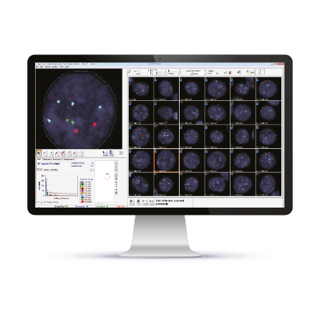

Product Options
Catalog # | Product Name

Software
FPRSF0136 | LabLife™ software license for measurement, management, and reporting of the lab performance statistics
FPRSF0114 | SpotScan™ software license for FISH review and analysis for all sample types both cell suspension and tissue FISH
FPRSF0138 | TissueSuite™ FISH software license for on-screen matching of tissue FISH with external H&E image
FPRSF0111 | Multispecies™ software license for research and karyotyping of non-human (other species) samples

Accessories
FPRAC0135 | Monitor 27" resolution 2560X1440 (16:9)
FPRAC0092 | Handheld barcode reader  Zebra Technologies (1D Code 128 & 2D QR code)
FPRAC0147 | Programmed 24 Key USB Keypad


CytoPower
Digital Karyotyping &
FISH Analysis

CytoPower Manual System CPQBNS15-M
Karyotyping and FISH combined on a single manual microscope setup for integrated metaphase and FISH analysis.

CytoPower Manual System | Top Highlights

- Manual capture solution for both high-resolution metaphase and FISH imaging
- Suggested karyograms prepared during image capture and ready for immediate review
- Single "Magic Tool" for all karyogram corrections
- Vendor-agnostic FISH probe support across sample types
- Sequential FISH layer capture - manual or automatic

GenASIs 8.4.1 software inclusive  of the following licenses:  - Case Data Manager™ software license for data management, viewing, and archiving inclusive of network connectivity of multiple systems  - BandView™ software license for chromosome analysis and karyotyping inclusive of image acquisition module  - FISHView™ software license for Fluorescent Karyotyping, Image Enhancement and Documentation, Inclusive of mCounter and Image Acquisition Module  (optional can be replaced or in addition to SpotScan) | Capture & Analysis Platform  5MP CMOS Monochrome Camera  - 2/3" high resolution monochrome digital CMOS  - Resolution 2448 px X 2048 px  - Pixel size 3.45 µm x 3.45 µm  - Pixel depth 12 bit  - Interface USB3  Computer  - Tower Form  - Processor Intel Core i7-13700K  - Memory 16GB RAM  - Hard Drive 512GB SSD  - Operating system Microsoft Windows 11 or 10 64 Bit  Professional or Enterprise edition
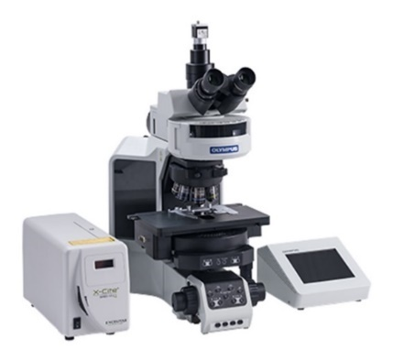
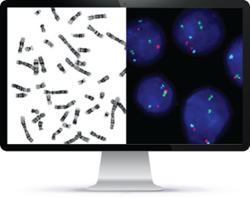

Product Options
Catalog # | Product Name

Software
FPRSF0155 | Aided Karyotyping™ software license, for automatic chromosome segmentation and classification  Note: Display card NVIDIA RTX-4060 8 GB is required
FPRSF0136 | LabLife™ software license for measurement, management, and reporting of the lab performance statistics
FPRSF0111 | Multispecies™ software license for research and karyotyping of non-human (other species) samples
FPRSF0138 | TissueSuite™ FISH software license for on-screen matching of tissue FISH with external H&E image
FPRSF0117 | SpotScan™ software license for scanning and image acquisition inclusive of FISH review and analysis for all sample types both cell suspension and tissue
FPRSF0114 | SpotScan™ software license for FISH review and analysis for all sample types both cell suspension and tissue FISH
FPRSF0119 | MetScan™ Gallery software license for review and selection of acquired metaphases
FPRSF0122 | MNScore™ software license for review of scored Cytokinesis-blocked micronucleus

Accessories
FPRAC0135 | Monitor 27" resolution 2560X1440 (16:9)
FPRAC0092 | Handheld barcode reader  Zebra Technologies (1D Code 128 & 2D QR code)
FPRAC0147 | Programmed 24 Key USB Keypad

Microscope Accessories
FPRAC0137 | C-Mount 0.5X

CytoPower Scanning System CPQBNS15-S
Karyotyping and FISH scanning systems combined on a single automated platform for integrated metaphase and FISH imaging and analysis.

CytoPower Scanning System | Top Highlights

- Metaphase scan at 10x with high-res capture at 100x
- Suggested karyograms prepared during scanning and ready for immediate review
- Automated FISH signal detection and cell classification for standardized quantitative results
- Vendor-agnostic FISH probe support across sample types
- Automated tissue FISH workflows including tissue matching with H&E or IHC image to guide tumor marking

GenASIs 8.4.1 software inclusive  of the following licenses:  - Case Data Manager™ software license for data management, viewing, and archiving inclusive of network connectivity of multiple systems  - SpotScan™ software license for scanning and image acquisition inclusive of FISH review and analysis for all sample types both cell suspension and tissue  - MetScan™ software license for scanning and detection of metaphases, including automated image acquisition of metaphases  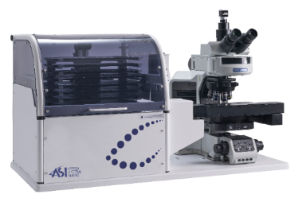  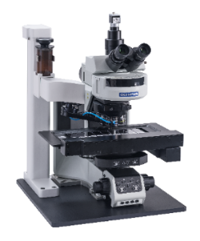  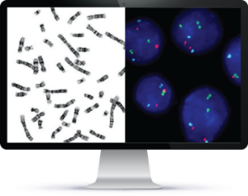 | Scan & Analysis Platform  5MP CMOS Monochrome Camera  - 2/3" high resolution monochrome digital CMOS  - Resolution 2448 px X 2048 px  - Pixel size 3.45 µm x 3.45 µm  - Pixel depth 12 bit  - Interface USB3  Motorized Scanning Stage  - Tray for 9 slides capacity  - Joystick 2 axis, 4 fast function buttons  - ASI Controller  Computer  - Tower Form Series PC  - Processor Intel Core Processor i7-13700K  - Display card NVIDIA RTX-4060 8 GB  - Memory 16GB RAM  - Hard Drive 512GB SSD  - Operating system Microsoft Windows 11 or 10 64 Bit  Professional or Enterprise edition

Product Options
Catalog # | Product Name

Software
FPRSF0155 | Aided Karyotyping™ software license, for automatic chromosome segmentation and classification
FPRSF0136 | LabLife™ software license for measurement, management, and reporting of the lab performance statistics
FPRSF0143 | FISHView™ software license for Fluorescent Karyotyping, Image Enhancement and Documentation,  Inclusive of mCounter and Image Acquisition Module
FPRSF0138 | TissueSuite™ FISH software license for on-screen Matching of tissue FISH with External H&E Image
FPRSF0121 | MNScore™ software license for scanning and scoring of Cytokinesis-blocked micronucleus
FPRSF0109 | BandView™ software license for chromosome analysis and karyotyping inclusive of image acquisition module
FPRSF0111 | Multispecies™ software license for research and karyotyping of non-human (other species) samples

Tray Loader
FPRAC0127 | Tray Loader™ (1D) for 99+ slides capacity inclusive of  11 slide trays  Barcode printer, labels (5 rolls) and ribbons (2)  1D barcode reader  Automated oil dispenser
FPRAC0128 | Tray Loader™ (2D) for 99+ slides capacity inclusive of  11 slide trays  Barcode printer, labels (5 rolls) and ribbons (2)  2D barcode reader  Automated oil dispenser

Accessories
FPRAC0054 | Automated oil dispenser for 9-slides Scanner  Peristaltic oil pump  Reservoir of 150 ml
FPRAC0135 | Monitor 27" resolution 2560X1440 (16:9)
FPRAC0155 | Barcode printer Zebra Technologies ZD621T (Customized to ASI products)
FPRAC0092 | Handheld barcode reader  Zebra Technologies (1D Code 128 & 2D QR code)
FPRAC0044 | GenASIs Lightsaver controller
FPRAC0147 | Programmed 24 Key USB Keypad

Microscope Accessories
FPRAC0137 | C-Mount 0.5X

Fluorescent Filter Sets

Please contact ASI for details

CytoPower Review System CPQBNS15-R
Dedicated workstation for analyzing, reviewing and signing-off digital karyograms and FISH results.

CytoPower Review System | Top Highlights

- Suggested karyograms ready for immediate review
- Homolog comparison within/between cases
- Gallery-based review of detected FISH signals, classified cells and quantitative results
- FISH result review from multiple readers via supervisor mode
- Custom case report with karyotype and/or FISH summary

GenASIs 8.4.1 software inclusive  of the following licenses:  - Case Data Manager™ software license for data management, viewing, and archiving inclusive of network connectivity of multiple systems  - BandView™ software license for chromosome analysis and karyotyping  - FISHView™ or SpotScan™ software license  At least one of these is required. If SpotScan is installed on the main system (scanner or manual), it must also be installed on the review station | Review & Analysis Platform  Computer  - Processor Intel Core i7-13700K  - Memory 16GB RAM  - Hard Drive 512GB SSD  - Operating system Microsoft  Windows 11 or 10 64 Bit Professional  or Enterprise edition
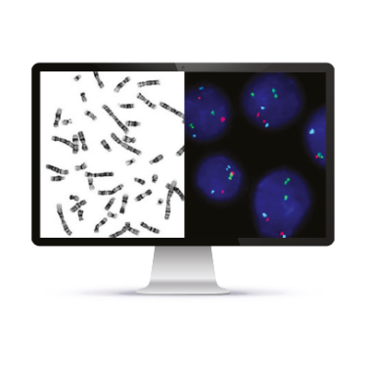

Product Options
Catalog # | Product Name

Software
FPRSF0155 | Aided Karyotyping™ software license, for automatic chromosome segmentation and classification  Note: Display card NVIDIA RTX-4060 8 GB is required depending on workflow
FPRSF0136 | LabLife™ software license for measurement, management, and reporting of the lab performance statistics
FPRSF0114 | SpotScan™ software license for FISH review and analysis for all sample types both cell suspension and tissue FISH
FPRSF0119 | MetScan™ Gallery software license for review and selection of acquired metaphases
FPRSF0138 | TissueSuite™ FISH software license for on-screen matching of tissue FISH with external H&E Image
FPRSF0113 | HiSKY™ software license for review and spectral karyotyping
FPRSF0122 | MNScore™ software license for review of scored Cytokinesis-blocked micronucleus
FPRSF0111 | Multispecies™ software license for research and karyotyping of non-human (other species) samples

Accessories
FPRAC0135 | Monitor 27" resolution 2560X1440 (16:9)
FPRAC0092 | Handheld barcode reader  Zebra Technologies (1D Code 128 & 2D QR code)
FPRAC0147 | Programmed 24 Key USB Keypad

CytoPower ScanLink Cyto System CPQBNS003
Full digital karyotyping from third-party metaphase images using computer-aided chromosome analysis.

CytoPower ScanLink Cyto System | Top Highlights

- Suggested karyograms prepared on metaphase images acquired on third-party scanner
- Single "Magic Tool" for all karyogram corrections
- Easy ideogram creation with ISCN-ready output
- Homolog comparison within/between cases
- Custom reports with clone summary and common aberrations

GenASIs 8.4.1 software inclusive  of the following licenses:  - Case Data Manager™ software license for data management, viewing, and archiving inclusive of network connectivity of multiple systems  - ScanLink Cyto™ software license | ScanLink Cyto Platform  Computer  - Processor Intel Core i7-13500  - Memory 16GB RAM  - Display card NVIDIA RTX-4060 8 GB  - Hard Drive 512GB SSD  - Operating system Microsoft  - Windows 11 or 10 64 Bit  Professional or Enterprise edition

Product Options
Catalog # | Product Name

Software
FPRSF0109 | BandView™ software license for chromosome analysis and karyotyping inclusive of image acquisition module

Accessories
FPRAC0135 | Monitor 27" resolution 2560X1440 (16:9)

CytoPower HyperSpectral System CPQBNS15-SP
Spectral Karyotyping (SKY) FISH-based method to label each chromosome with a unique color, allowing clear visualization of all chromosomes in one image.

CytoPower HyperSpectral System | Top Highlights

- Measurement of entire spectrum at each point to extract emission of each dye
- Single button for simultaneously excitation and acquisition using ASI's Spectral Cube
- Simultaneous detection of chromosomal aberrations in one hybridization
- Automatic identification of translocations and chromosomal origins
- Dedicated chromosome paints for human and mouse samples

GenASIs 8.4.1 software inclusive  of the following licenses:  - Case Data Manager™ software license for data management, viewing, and archiving inclusive of network connectivity of multiple systems  - HiSKY™ software license for spectral image acquisition and karyotyping  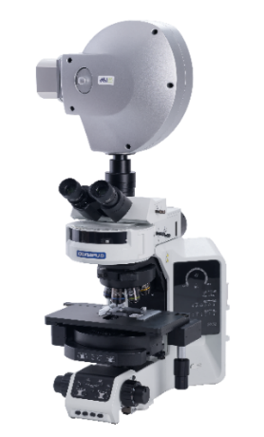  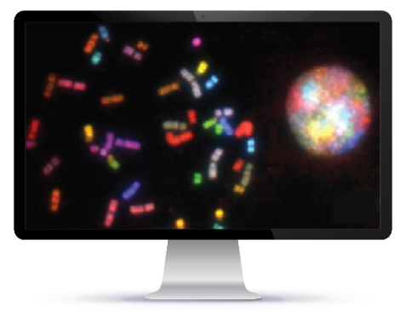  - Multispecies™ software license for research and karyotyping of non-human (other species) samples | HyperSpectral Platform  Spectra Cube  - Simultaneous capture of 1.3 MP spectra  - Spectral range 400-1000nm  - Dual capture mode: Monochromatic & Hyperspectral  - Pixel depth 16 bit  - Microscope support: upright and Inverted  - Illumination modes: brightfield, fluorescence and reflection  - Non polarized optical path  High End Computer  - Tower Form Series PC  - Intel® Xeon® 4-Core W-2123 (8.25M Cache, 3.6GHz,)  - Memory 16GB RAM  - Hard Drive 1TB  - Display card NVIDIA® Quadro® P2000 5GB (4 DP)  - Operating system Microsoft Windows 11 or 10 64 Bit  Professional or Enterprise edition  SKY Filter Set  Starter Reagent Kit (4 tests)

Product Options
Catalog # | Product Name

Software
FPRSF0136 | LabLife™ software license for measurement, management, and reporting of the lab performance statistics
FPRSF0109 | BandView™ software license for chromosome analysis and karyotyping
FPRSF0107 | FISHView™ software license for Fluorescent Karyotyping, Image Enhancement and Documentation, Inclusive of mCounter and Image Acquisition Module
FPRSF0119 | MetScan™ Gallery software license for review and selection of acquired metaphases
FPRSF0117 | SpotScan™ software license for scanning and image acquisition inclusive of FISH review and analysis for all sample types both cell suspension and tissue
FPRSF0114 | SpotScan™ software license for FISH review and analysis for all sample types both cell suspension and tissue FISH
FPRSF0122 | MNScore™ software license for the review of scored Cytokinesis-blocked micronucleus

Accessories
FPRAC0135 | Monitor 27" resolution 2560X1440 (16:9)
FPRAC0092 | Handheld barcode reader  Zebra Technologies (1D Code 128 & 2D QR code)
FPRAC0147 | Programmed 24 Key USB Keypad

Microscope Accessories
FPRAC0012 | C-Mount 1X



HiPath Pro
Brightfield Digital Pathology

HiPath Pro Manual System CPQBNS04-M
High-resolution digital pathology imaging and analysis on a manual microscope setup for brightfield specimens.

HiPath Pro Manual System | Top Highlights

- Manual acquisition of frames from digital pathology slides at 20x magnification
- Multiple tools for ROI definition and analysis
- Automated quantitative analysis of IHC expression on membrane and nuclear stains
- Customized case report summarizing quantitative results

GenASIs 8.4.1 software inclusive  of the following licenses:  - Case Data Manager™ software license for data management, viewing, and archiving inclusive of network connectivity of multiple systems  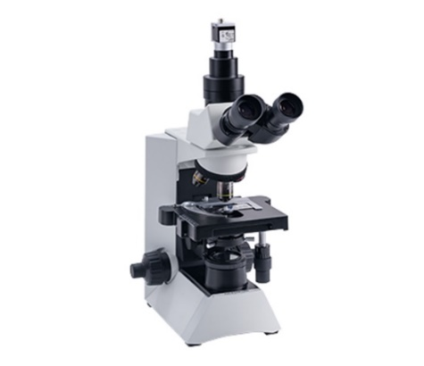  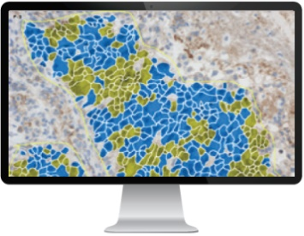  - HiPath™ IHC Family software bundle inclusive of IHC Membrane, IHC Nuclear and PD-L1 analysis software license and image acquisition module | Capture & Analysis Platform  5MP CMOS Color Camera  - 2/3" high resolution color digital CMOS  - Resolution 2448 px X 2048 px  - Pixel size 3.45 µm x 3.45 µm  - Pixel depth 12 bit  - Interface USB3  Programmable Foot Switch  Computer  - Tower Form  - Processor Intel Core i7-13700K  - Memory 16GB RAM  - Hard Drive 512GB SSD  - Microsoft Windows 11 or 10 64 Bit  Professional or Enterprise edition

Product Options
Catalog # | Product Name

Software
FPRSF0136 | LabLife™ software license for measurement, management, and reporting of the lab performance statistics
FPRSF0129 | TissueSuite™ Brightfield software license for whole slide image viewing, annotating, and measuring  (only compatible if connected to a WSI scanning station)
FPRSF0141 | HiSlide™ software license for capture & review an image from all different slide staining that ASI doesn’t  have a dedicated algorithm for
FPRSF0127 | CISH™ software license for analysis of CISH stain, inclusive of image acquisition module

Accessories
FPRAC0135 | Monitor 27" resolution 2560X1440 (16:9)
FPRAC0162 | Barco 27” Pathology Monitor
FPRAC0092 | Handheld barcode reader  Zebra Technologies (1D Code 128 & 2D QR code)

Microscope Accessories
FPRAC0137 | C-Mount 0.5X

HiPath Pro Scanning System CPQBNS04-S
Whole-slide imaging (WSI) of H&E and IHC with automated quantitative analysis for IHC.

HiPath Pro Scanning System | Top Highlights

- Whole slide imaging (WSI) of H&E/IHC slides up to 80x digital magnification
- Tissue matching with automatic ROI transfer across aligned images
- Vendor-agnostic quantitative image analysis for ER, PR, HER2, Ki67, P53, PD-L1 and more
- Separate documentation of control region analysis for regulatory compliance
- Customized case report summarizing quantitative results

GenASIs 8.4.1 software inclusive  of the following licenses:  - Case Data Manager™ software license for data management, viewing, and archiving inclusive of network connectivity of multiple systems  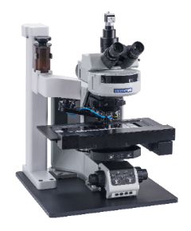  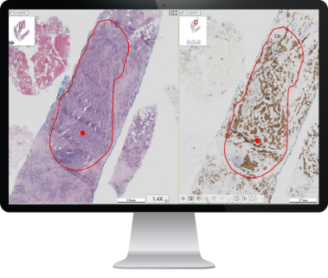  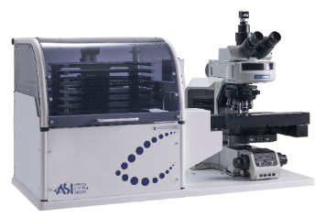  - SlideScan™ software license for high magnification, bright field whole slide imaging | Scan & Analysis Platform  5MP CMOS Color Camera  - 2/3" high resolution color digital CMOS  - Resolution 2448 px X 2048 px  - Pixel size 3.45 µm x 3.45 µm  - Pixel depth 12 bit  - Interface USB3  Motorized Scanning Stage  - Tray for 9 slides capacity  - Joystick 2 axis, 4 fast function buttons  - ASI Controller  High End Computer  - Tower Form Series PC  - Processor Intel Core Processor i7-13700K  - Memory 64GB RAM  - Hard Drive 1TB SSD  - Display card NVIDIA RTX-4060 8 GB  - Operating system Microsoft Windows 11 or 10 64 Bit  Professional or Enterprise edition

Product Options
Catalog # | Product Name

Software
FPRSF0136 | LabLife™ software license for measurement, management, and reporting of the lab performance statistics
FPRSF0129 | TissueSuite™ Brightfield software license for whole slide image viewing, annotating, and measuring
FPRSF0146 | IHC WSI Analysis™ Software License for analysis and documentation of WSI IHC samples inclusive of membrane, nuclear and PD-L1 stain

Tray Loader
FPRAC0133 | Tray Loader™ (1D) for 99+ slides capacity inclusive of  11 slide trays  Barcode Printer, labels (5 rolls) and ribbons (2)  1D barcode reader
FPRAC0134 | Tray Loader™ (2D) for 99+ slides capacity inclusive of  11 slide trays  Barcode printer, labels (5 rolls) and ribbons (2)  2D barcode reader

Accessories
FPRAC0135 | Monitor 27" resolution 2560X1440 (16:9)
FPRAC0162 | Barco 27” Pathology Monitor
FPRAC0155 | Barcode printer Zebra Technologies ZD621T (Customized to ASI products)
FPRAC0092 | Handheld barcode reader  Zebra Technologies (1D Code 128 & 2D QR code)

Microscope Accessories
FPRAC0137 | C-Mount 0.5X

HiPath Pro Review System CPQBNS04-R
Dedicated workstation for analysis, reviewing and signing-off brightfield pathology cases.

HiPath Pro Review System | Top Highlights

- Compared analysis of up to 4 brightfield pathology images side-by-side
- Tissue matching with automatic ROI transfer across aligned images
- Vendor-agnostic quantitative image analysis for ER, PR, HER2, Ki67, P53, PD-L1 and more
- Separate documentation of control region analysis for regulatory compliance
- Customized case report summarizing quantitative results

GenASIs 8.4.1 software inclusive  of the following licenses:  - Case Data Manager™ software license for data management, viewing, and archiving inclusive of network connectivity of multiple systems  - TissueSuite™ BrightField software license for Whole Slide Image viewing, annotating, and measuring  (only compatible if connected to a WSI scanning station)  - IHC analysis™ software - optional | Review & Analysis Platform  Computer  - Processor Intel Core i7-13700K  - Memory 16GB RAM  - Hard Drive 512GB SSD  - Operating system Microsoft  Windows 11 or 10 64 Bit  Professional or Enterprise edition
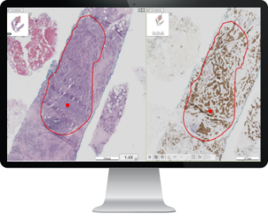

Product Options
Catalog # | Product Name

Software
FPRSF0136 | LabLife™ software license for measurement, management, and reporting of the lab performance statistics
FPRSF0135 | CISH™ Analysis software license
FPRSF0146 | IHC WSI Analysis™ Software License for analysis and documentation of WSI IHC samples inclusive of  membrane, nuclear and PD-L1 stain (compatible if connected to a WSI scanning station)
FPRSF0134 | HiPath™ IHC Family software bundle inclusive of IHC Membrane, IHC Nuclear and PD-L1 analysis software license and image acquisition module (compatible if connected to a HiPath Manual station)
FPRSF0142 | HiSlide™ software license for reviewing only of an image from all different slide staining that ASI doesn’t  have a dedicated algorithm for

Accessories
FPRAC0135 | Monitor 27" resolution 2560X1440 (16:9)
FPRAC0162 | Barco 27” Pathology Monitor
FPRAC0092 | Handheld barcode reader  Zebra Technologies (1D Code 128 & 2D QR code)

HiPath Pro ScanLink Pathology System CPQBNS004
Seamless brightfield WSI import from external scanners into HiPath Pro for viewing and analysis.

HiPath Pro ScanLink Pathology System | Top Highlights

- Tissue matching with automatic ROI transfer across aligned images
- Vendor-agnostic quantitative image analysis for ER, PR, HER2, Ki67, P53, PD-L1 and more
- Separate documentation of control region analysis for regulatory compliance
- Customized case report summarizing quantitative results

HiPath Pro ScanLink Pathology System  CPQBNS004  GenASIs 8.4.1 software inclusive  of the following licenses:  - Case Data Manager™ software license for data management, viewing, and archiving inclusive of network connectivity of multiple systems  - ScanLink™ software license | ScanLink Pathology Platform  Computer  - Processor Intel Core i7-13700K  - Memory 16GB RAM  - Hard Drive 512GB SSD  - Operating system Microsoft  - Windows 11 or 10 64 Bit  - Professional or Enterprise edition
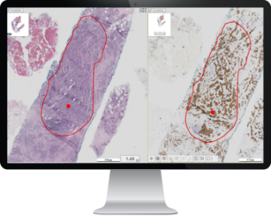

Product Options
Catalog # | Product Name

Accessories
FPRAC0135 | Monitor 27" resolution 2560X1440 (16:9)

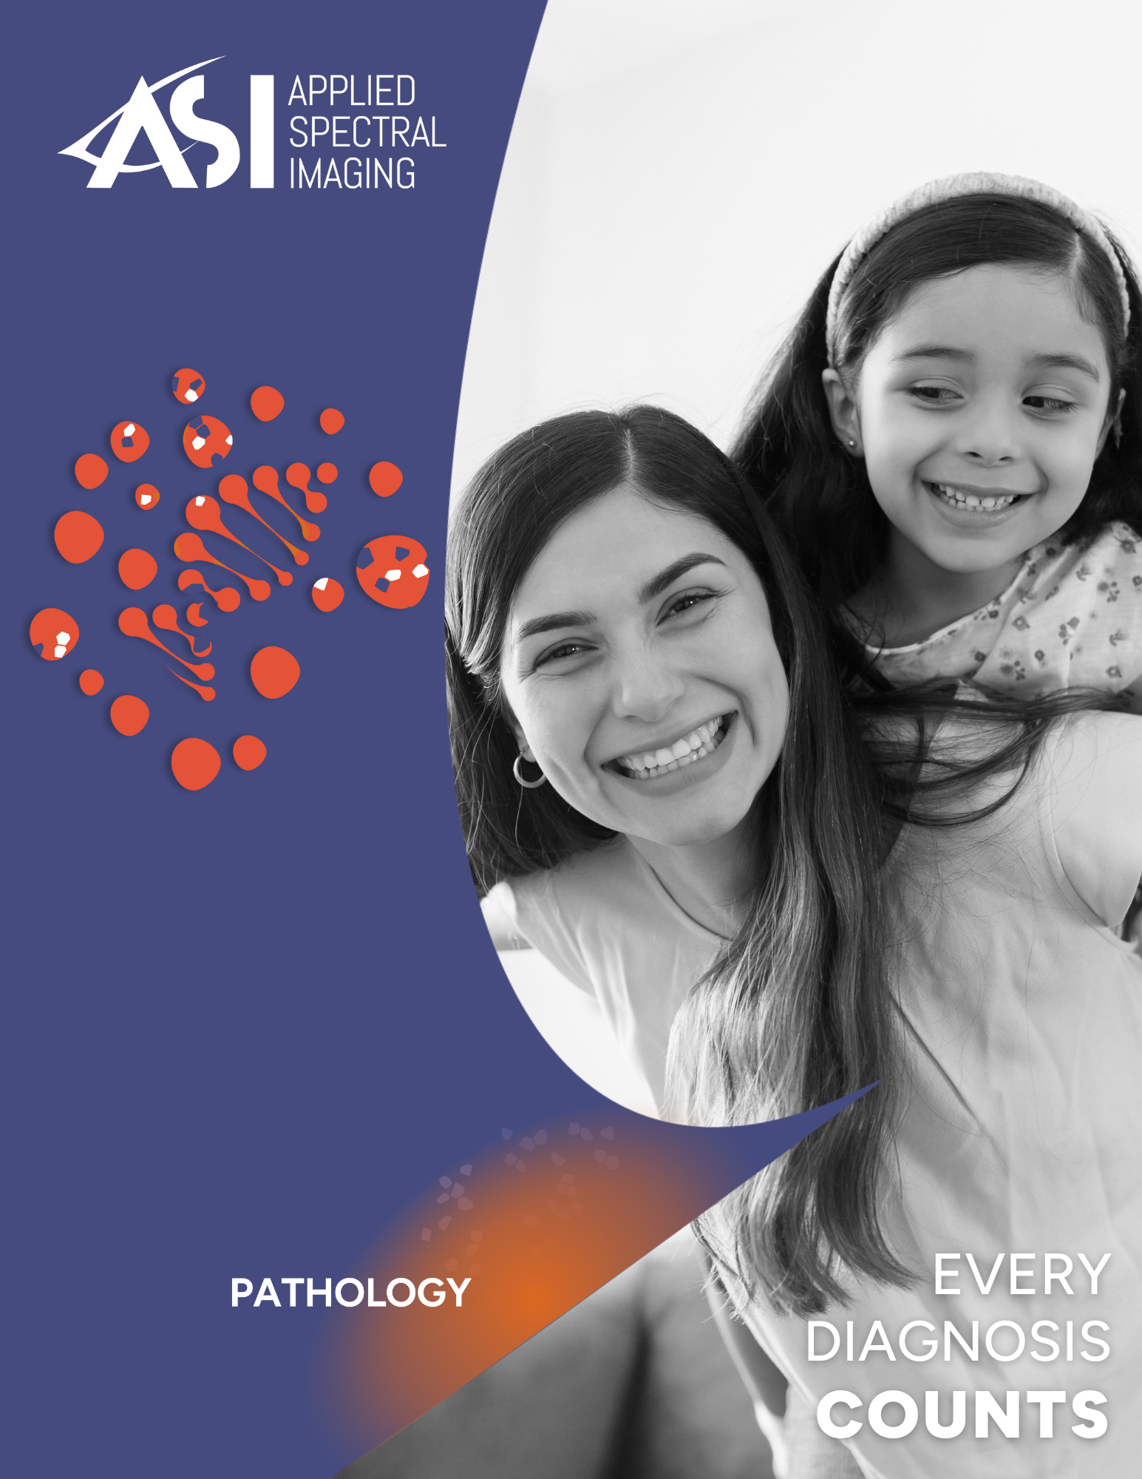

PathFusion
Full Pathology Imaging Suite
H&E | IHC | FISH

PathFusion Manual System CPQBNS03-M
Digital pathology on manual microscopes - brightfield and fluorescence supported.

PathFusion Manual System | Top Highlights

- Manual frame capture from H&E, IHC, IF, and FISH slides at user-defined magnification
- High-resolution FISH imaging and analysis with instant Z-stack of multiple focal planes
- Vendor-agnostic FISH analysis for all tissue types
- Automated quantification of IHC membrane and nuclear staining
- Customized case report summarizing quantitative results

GenASIs 8.4.1 software inclusive  of the following licenses:  - Case Data Manager™ software license for data management, viewing, and archiving inclusive of network connectivity of multiple systems  - HiPath™ IHC Family software bundle inclusive of IHC Membrane, IHC Nuclear and PD-L1 analysis software license and image acquisition module  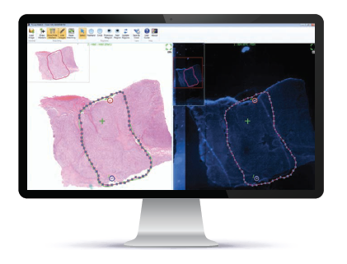  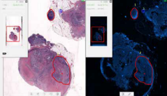  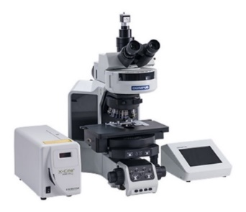  - FISHView™ software license for Fluorescent Karyotyping, Image Enhancement and Documentation, Inclusive of mCounter and Image Acquisition Module | Capture & Analysis Platform  5MP CMOS Color Camera  - 2/3" high resolution color digital CMOS  - Resolution 2448 px X 2048 px  - Pixel size 3.45 µm x 3.45 µm  - Pixel depth 12 bit  - Interface USB3  Programmable Foot Switch  Computer  - Tower Form  - Processor Intel Core i7-13700K  - Memory 16GB RAM  - Hard Drive 512GB SSD  - Operating system Microsoft Windows 11 or 10 64Bit  Professional or Enterprise edition

Product Options
Catalog # | Product Name

Software
FPRSF0136 | LabLife™ software license for measurement, management, and reporting of the lab performance statistics
FPRSF0117 | SpotScan™ software license for scanning and image acquisition inclusive of FISH review and analysis for all sample types both cell suspension and tissue
FPRSF0114 | SpotScan™ software license for FISH review and analysis
FPRSF0127 | CISH™ software license for analysis of CISH stain, inclusive of image acquisition module
FPRSF0129 | TissueSuite™ Brightfield software license for whole slide image viewing, annotating, and measuring  (only compatible if connected to a WSI scanning station)
FPRSF0138 | TissueSuite™ FISH software license for on-screen matching of tissue FISH with external H&E image

Accessories
FPRAC0135 | Monitor 27" resolution 2560X1440 (16:9)
FPRAC0162 | Barco 27” Pathology Monitor
FPRAC0092 | Handheld barcode reader  Zebra Technologies (1D Code 128 & 2D QR code)
FPRAC0147 | Programmed 24 Key USB Keypad

Microscope Accessories
FPRAC0137 | C-Mount 0.5X

Fluorescent Filter Sets

Please contact ASI for details

PathFusion Scanning System CPQBNS03-S
Full automation for scanning and analyzing brightfield and fluorescent pathology slides.

PathFusion Scanning System | Top Highlights

- H&E, IHC, IF, and FISH slide scanning on a single platform
- Unified platform for reviewing and analyzing brightfield and fluorescent specimens
- Automated tissue FISH with tumor marking guided by matched H&E or IHC images
- Probe vendor-agnostic tissue FISH analysis with automated cell segmentation, signal detection and quantification
- Automated quantification of IHC membrane and nuclear expression

GenASIs 8.4.1 software inclusive  of the following licenses:  - Case Data Manager™ software license for data management, viewing, and archiving inclusive of network connectivity of multiple systems  - SlideScan™ software license for high magnification, bright field whole slide imaging  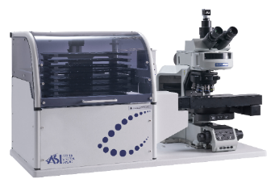  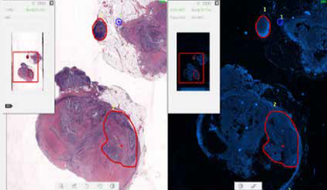  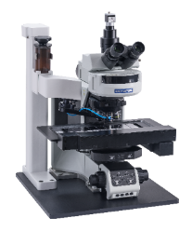  - SpotScan™ software license for scanning and image acquisition inclusive of FISH review and analysis for  all sample types both cell suspension and tissue | Scan & Analysis Platform  5MP CMOS Color Camera  - 2/3" high resolution color digital CMOS  - Resolution 2448 px X 2048 px  - Pixel size 3.45 µm x 3.45 µm  - Pixel depth 12 bit  - Interface USB3  Motorized Scanning Stage  - Tray for 9 slides capacity  - Joystick 2 axis, 4 fast function buttons  - ASI Controller  High End Computer  - Tower Form Series PC  - Processor Intel Core i7-13700K  - Memory 64GB RAM  - Hard Drive 1TB SSD  - Display card NVIDIA RTX-4060 8 GB  - Operating system Microsoft Windows 11 or 10 64 Bit  Professional or Enterprise edition

Product Options
Catalog # | Product Name

Software
FPRSF0136 | LabLife™ software license for measurement, management, and reporting of the lab performance statistics
FPRSF0146 | IHC WSI Analysis™ Software License for analysis and documentation of WSI IHC samples inclusive of membrane, nuclear and PD-L1 stain
FPRSF0129 | TissueSuite Brightfield™ software license for whole slide image viewing, annotating, and measuring
FPRSF0138 | TissueSuite™ FISH software license for on-screen matching of tissue FISH with external H&E image
FPRSF0143 | FISHView™ software license for Fluorescent Karyotyping, Image Enhancement and Documentation,  Inclusive of mCounter and Image Acquisition Module

Tray Loader
FPRAC0127 | Tray Loader™ (1D) for 99+ slides capacity inclusive of  11 slide trays  Barcode printer, labels (5 rolls) and ribbons (2)  1D barcode reader  Automated oil dispenser
FPRAC0128 | Tray Loader™ (2D) for 99+ slides capacity inclusive of  11 slide trays  Barcode printer, labels (5 rolls) and ribbons (2)  2D barcode reader  Automated oil dispenser

Accessories
FPRAC0054 | Automated oil dispenser for 9-slides scanner  Peristaltic oil pump  Reservoir of 150 ml
FPRAC0135 | Monitor 27" resolution 2560X1440 (16:9)
FPRAC0162 | Barco 27” Pathology Monitor
FPRAC0155 | Barcode printer Zebra Technologies ZD621T (Customized to ASI products)
FPRAC0092 | Handheld barcode reader  Zebra Technologies (1D Code 128 & 2D QR code)
FPRAC0147 | Programmed 24 Key USB Keypad

Microscope Accessories
FPRAC0137 | C-Mount 0.5X

Fluorescent Filter Sets

Please contact ASI for details

PathFusion Review System CPQBNS03-R1
Dedicated workstation for analysis, reviewing and signing-off brightfield and fluorescent pathology cases.

PathFusion Review System | Top Highlights

- Unified platform for reviewing and analyzing brightfield and fluorescent specimens
- Tissue matching and automatic transfer of regions of interest across registered images
- Probe vendor-agnostic tissue FISH analysis with automated cell segmentation, signal detection and quantification
- Automated quantification of IHC membrane and nuclear expression
- Customized case report summarizing quantitative results

GenASIs 8.4.1 software inclusive  of the following licenses:  - Case Data Manager™ software license for data management, viewing, and archiving inclusive of network connectivity of multiple systems  - TissueSuite™ Brightfield software license for Whole Slide Image viewing, annotating, and measuring  - TissueSuite™ FISH software license for on-screen matching of tissue FISH with external H&E image  - SpotScan™ software license for FISH review and analysis for all sample types both cell suspension and tissue FISH  - IHC analysis™ software - optional | Review & Analysis Platform  Computer  - Processor Intel Core i7-13700K  - Memory 16GB RAM  - Hard Drive 512GB SSD  - Operating system Microsoft  Windows 11 or 10 64 Bit  Professional or Enterprise edition
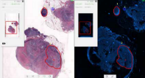

Product Options
Catalog # | Product Name

Software
FPRSF0136 | LabLife™ software license for measurement, management, and reporting of the lab performance statistics
FPRSF0146 | IHC WSI Analysis™ Software License for analysis and documentation of WSI IHC samples inclusive of membrane, nuclear and PD-L1 stain (only compatible if connected to a WSI scanning station)
FPRSF0134 | HiPath™ IHC Family software bundle inclusive of IHC Membrane, IHC Nuclear and PD-L1 analysis software license and image acquisition module (only compatible if connected to a HiPath or PathFusion Manual station)
FPRSF0108 | FISHView™ software license for fluorescent karyotyping, image enhancement and documentation
FPRSF0135 | CISH™ Analysis software license

Accessories
FPRAC0135 | Monitor 27" resolution 2560X1440 (16:9)
FPRAC0162 | Barco 27” Pathology Monitor
FPRAC0092 | Handheld barcode reader  Zebra Technologies (1D Code 128 & 2D QR code)
FPRAC0147 | Programmed 24 Key USB Keypad

PathFusion ScanLink Pathology System CPQBNS004

Seamless import of third-party brightfield WSI for analysis in ASI’s PathFusion.

PathFusion ScanLink Pathology | Top Highlights

- Vendor-agnostic quantitative image analysis for ER, PR, HER2, Ki67, P53, PD-L1 and more
- Tissue matching between H&E or IHC images acquired on third-part scanner and ASI's FISH scan
- Automatic transfer of regions of interest from brightfield to registered FISH image
- Customized case report summarizing quantitative results

GenASIs 8.4.1 software inclusive  of the following licenses:  - Case Data Manager™ software license for data management, viewing, and archiving inclusive of network connectivity of multiple systems  - ScanLink™ software license | ScanLink Pathology Platform  Computer  - Processor Intel Core i7-13700K  - Memory 16GB RAM  - Hard Drive 512GB SSD  - Operating system Microsoft  - Windows 11 or 10 64 Bit  - Professional or Enterprise edition

Product Options
Catalog # | Product Name

Accessories
FPRAC0135 | Monitor 27" resolution 2560X1440 (16:9)



Pathology Research

HyperSpectral System CPQBNS10
Advanced configuration for spectral imaging and multi-color FISH.

HyperSpectral System | Top Highlights

- Measurement of entire spectrum at each point to extract emission of each dye
- Dedicated license for quantitative analysis and multicolor unmixing
- Simultaneous detection of chromosomal aberrations in one hybridization
- Ideal for research on complex chromosomal aberrations marker identification
- Dedicated chromosome paints for human and multispecies samples

GenASIs 8.4.1 software inclusive  of the following licenses:  - Case Data Manager™ software license for data management, viewing, and archiving inclusive of network connectivity of multiple systems  - SpectraView™ Software License for quantitative analysis and multicolor unmixing, inclusive of spectral image acquisition module  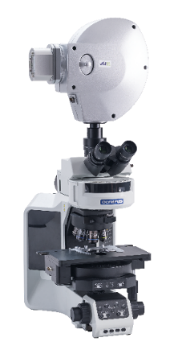  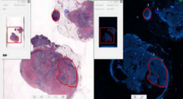  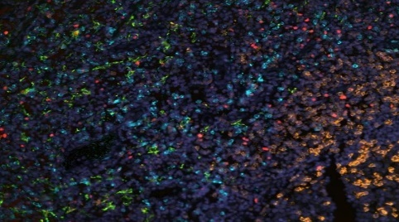 | HyperSpectral Platform  Spectra Cube  - Simultaneous capture of 1.3 MP spectra  - Spectral range 400-1000nm  - User defined spectral resolution (FWHM) 6-40nm  Minimum FWHM of 3nm is achievable with customized system setup  - Dual capture mode: Monochromatic & Hyperspectral  - Pixel depth 16 bit  - Microscope support: upright and Inverted  - Illumination modes: brightfield, fluorescence and reflection  - Non polarized optical path  High End Computer  - Tower Form Series PC  - Intel® Xeon® 4-Core W-2123 (8.25M Cache, 3.6GHz,)  - Memory 16GB RAM  - Hard Drive 1TB  - Display card NVIDIA® Quadro® P2000 5GB (4 DP)  - Operating system Microsoft Windows 10 or 11 64 Bit  Professional or Enterprise edition

Product Options
Catalog # | Product Name

Software
FPRSF0136 | LabLife™ software license for measurement, management, and reporting of the lab performance statistics

Accessories
FPRAC0135 | Monitor 27" resolution 2560X1440 (16:9)
FPRAC0092 | Handheld barcode reader  Zebra Technologies (1D Code 128 & 2D QR code)

Microscope Accessories
FPRAC0012 | C-Mount 1X
HWFLT0169 | F/C Orthogonal (SpectraView) for fluorescent applications covering a range of 450-750nm



GenASIs
All-in-One
System

GenASIs All-in-One Manual System CPQBNS16-M
All-in-One Cytogenetics & Pathology Solution integrating karyotyping, FISH, and IHC imaging and analysis on a single manual microscope setup.

GenASIs All-in-One Manual System | Top Highlights
- Manual frame capture from H&E, IHC, IF, and FISH slides at user-defined magnification
- High-resolution FISH imaging and analysis with instant Z-stack of multiple focal planes
- Suggested karyograms prepared during image capture and ready for immediate review
- Automated quantification of IHC membrane and nuclear staining
- Customized case report summarizing quantitative results

GenASIs 8.4.1 software inclusive of the following licenses:  - Case Data Manager™ software license for data management, viewing, and archiving inclusive of network connectivity of multiple systems  - BandView™ software license for chromosome analysis and karyotyping  - FISHView™ software license for Fluorescent Karyotyping, Image Enhancement and Documentation, Inclusive of mCounter and Image Acquisition Module  - HiPath™ IHC Family software bundle inclusive of IHC Membrane, IHC Nuclear and PD-L1 analysis software license and image acquisition module  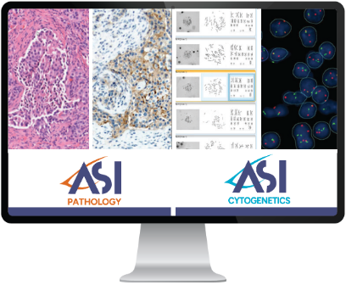  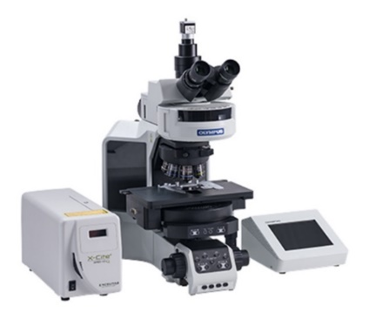  *Please note the SW is not mandatory and it is customizable. | Capture & Analysis Platform  5MP CMOS Color Camera  - 2/3" high resolution color digital CMOS  - Resolution 2448 px X 2048 px  - Pixel size 3.45 µm x 3.45 µm  - Pixel depth 12 bit  - Interface USB3  Programmable Foot Switch  Computer  - Tower Form  - Processor Intel Core i7-13700K  - Memory 16GB RAM  - Hard Drive 512GB SSD  - Operating system Microsoft Windows 11 or 10 64 Bit  Professional or Enterprise edition

Product Options
Catalog # | Product Name

Software
FPRSF0155 | Aided Karyotyping™ software license, for automatic chromosome segmentation and classification  Note: Display card NVIDIA RTX-4060 8GB is required
FPRSF0136 | LabLife™ software license for measurement, management, and reporting of the lab performance statistics
FPRSF0117 | SpotScan™ software license for scanning and image acquisition inclusive of FISH review and analysis for all sample types both cell suspension and tissue
FPRSF0114 | SpotScan™ software license for FISH review and analysis for all sample types both cell suspension and tissue FISH
FPRSF0119 | MetScan™ Gallery software license for the review and selection of acquired metaphases
FPRSF0127 | CISH™ software license for analysis of CISH stain, inclusive of image acquisition module
FPRSF0111 | Multispecies™ software license for research and karyotyping of non-human (other species) samples
FPRSF0129 | TissueSuite™ Brightfield software license for whole slide image viewing, annotating, and measuring  (only compatible if connected to a WSI scanning station)
FPRSF0138 | TissueSuite™ FISH software license for on-screen matching of tissue FISH withe H&E image  (only compatible if connected to a WSI scanning station or for importing of external H&E/IHC image)
FPRSF0122 | MNScore™ software license for the review of scored Cytokinesis-blocked micronucleus

Accessories
FPRAC0135 | Monitor 27" resolution 2560X1440 (16:9)
FPRAC0092 | Handheld barcode reader  Zebra Technologies (1D Code 128 & 2D QR code)
FPRAC0147 | Programmed 24 Key USB Keypad

Microscope Accessories
FPRAC0137 | C-Mount 0.5X

Fluorescent Filter Sets

Please contact ASI for details

GenASIs All-in-One Scanning System CPQBNS16-S
All-in-One Automated Platform unifying scanning and analysis of metaphase, H&E, IHC, and FISH on a single system.

GenASIs All-in-One Scanning System | Top Highlights
- High-throughput scanning of metaphases, H&E, IHC, IF and FISH tissue and suspension on the same platform
- Suggested karyograms ready for immediate review
- Automated probe vendor-agnostic FISH signal detection and cell classification for standardized quantitative results
- Automated quantification of IHC membrane and nuclear staining
- Customized case report summarizing quantitative results

GenASIs 8.4.1 software inclusive of the following licenses:  - Case Data Manager™ software license for data management, viewing, and archiving inclusive of network connectivity of multiple systems  - MetScan™ software license for scanning and detection of metaphases, including automated image acquisition of metaphases  - SpotScan™ software license for scanning and image acquisition inclusive of FISH review and analysis for all sample types both cell suspension and tissue  - SlideScan™ software license for high magnification, bright field whole slide imaging  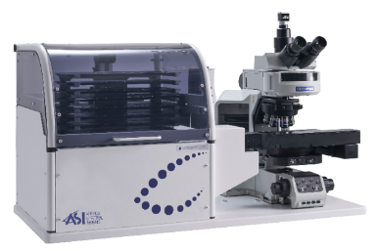  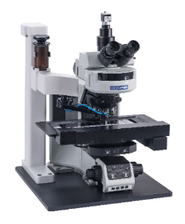  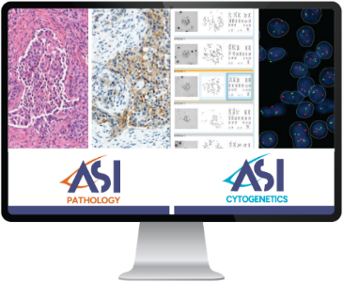  *Please note the SW is not mandatory and is customizable | Scan & Analysis Platform  5MP CMOS Color Camera  - 2/3" high resolution color digital CMOS  - Resolution 2448 px X 2048 px  - Pixel size 3.45 µm x 3.45 µm  - Pixel depth 12 bit  - Interface USB3  Motorized Scanning Stage  - Tray for 9 slides capacity  - Joystick 2 axis, 4 fast function buttons  - ASI Controller  High End Computer  - Tower Form Series PC  - Processor Intel Core Processor i7-13700K  - Display card NVIDIA RTX-4060 8GB  - Memory 64GB RAM  - Hard Drive 1TB SSD  - Operating system Microsoft Windows 11 or 10 64Bit  Professional or Enterprise edition

Product Options
Catalog # | Product Name

Software
FPRSF0155 | Aided Karyotyping™ software license, for automatic chromosome segmentation and classification
FPRSF0136 | LabLife™ software license for measurement, management, and reporting of the lab performance statistics
FPRSF0109 | BandView™ software license for chromosome analysis and karyotyping inclusive of image acquisition module
FPRSF0146 | IHC WSI Analysis™ Software License for analysis and documentation of WSI IHC samples inclusive of membrane, nuclear and PD-L1 stain
FPRSF0129 | TissueSuite Brightfield™ software license for whole slide image viewing, annotating, and measuring  (only compatible if connected to a WSI scanning station)
FPRSF0138 | TissueSuite™ FISH software license for on-screen matching of tissue FISH  (only compatible if connected to a WSI scanning station or using an external H&E image)
FPRSF0143 | FISHView™ software license for Fluorescent Karyotyping, Image Enhancement and Documentation, Inclusive of mCounter and Image Acquisition Module
FPRSF0111 | Multispecies™ software license for research and karyotyping of non-human (other species) samples
FPRSF0121 | MNScore™ software license for scanning and scoring of Cytokinesis-blocked micronucleus

Tray Loader
FPRAC0127 | Tray Loader™ (1D) for 99+ slides capacity inclusive of  11 slide trays  Barcode printer, labels (5 rolls) and ribbons (2)  1D barcode reader  Automated oil dispenser
FPRAC0128 | Tray Loader™ (2D) for 99+ slides capacity inclusive of  11 slide trays  Barcode printer, labels (5 rolls) and ribbons (2)  2D barcode reader  Automated oil dispenser

Product Options
Catalog # | Product Name | ASI Special Transfer Price

Accessories
FPRAC0054 | Automated oil dispenser for 9-slides Scanner  Peristaltic oil pump  Reservoir of 150 ml | $7,800
FPRAC0135 | Monitor 27" resolution 2560X1440 (16:9) | $1,450
FPRAC0155 | Barcode printer Zebra Technologies ZD621T (Customized to ASI products) | $2,750
FPRAC0092 | Handheld barcode reader  Zebra Technologies (1D Code 128 & 2D QR code) | $750
FPRAC0044 | GenASIs Lightsaver controller | $2,040
FPRAC0147 | Programmed 24 Key USB Keypad | $750

Microscope Accessories
FPRAC0137 | C-Mount 0.5X | $975

Fluorescent Filter Sets

Please contact ASI for details

GenASIs All-in-One Review System CPQBNS16-R
Dedicated workstation for analyzing, reviewing, and signing out cytogenetic, FISH and pathology cases.

GenASIs All-in-One Review System | Top Highlights
- Single environment for the review and analysis of karyograms, H&E, IHC, IF and FISH slides
- Suggested karyograms ready for immediate review
- Automated quantification of IHC membrane and nuclear staining
- Gallery-based review of detected FISH signals, classified cells and quantitative results
- Tissue matching and automatic transfer of regions of interest across brightfield or fluorescent images

GenASIs 8.4.1 software inclusive of the following licenses:  - Case Data Manager™ software license for data management, viewing, and archiving inclusive of network connectivity of multiple systems | Review & Analysis Platform  Computer  - Processor Intel Core i7-13700K  - Memory 16GB RAM  - Hard Drive 512GB SSD  - Operating system Microsoft  Windows 11 or 10 64 Bit  Professional or Enterprise edition
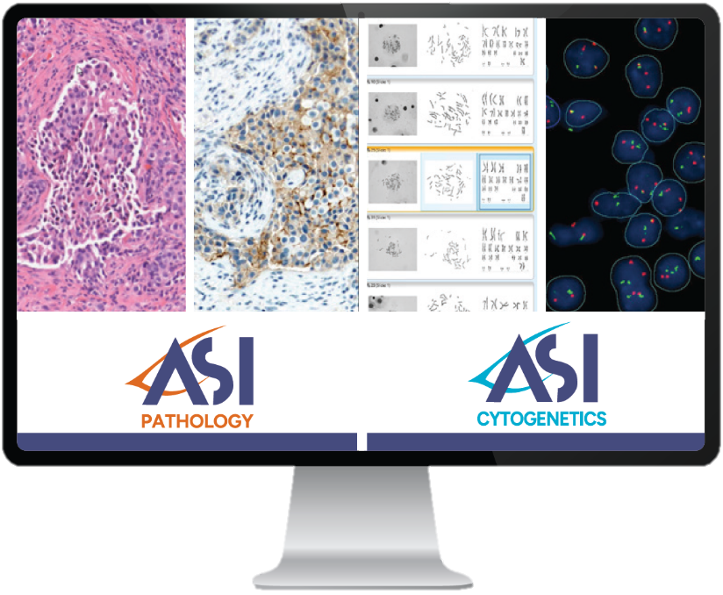

Product Options
Catalog # | Product Name

Software
FPRSF0136 | LabLife™ software license for measurement, management, and reporting of the lab performance statistics
FPRSF0129 | TissueSuite Brightfield™ software license for whole slide image viewing, annotating, and measuring  (only compatible if connected to a WSI scanning station)
FPRSF0138 | TissueSuite™ FISH software license for on-screen matching of tissue FISH  (only compatible if connected to a WSI scanning station or using an external H&E image)
FPRSF0114 | SpotScan™ software license for FISH review and analysis for all sample types both cell suspension and tissue FISH
FPRSF0146 | IHC WSI Analysis™ Software License for analysis and documentation of WSI IHC samples inclusive of  membrane, nuclear and PD-L1 stain
FPRSF0134 | HiPath™ IHC Family software bundle inclusive of IHC Membrane, IHC Nuclear and PD-L1 analysis software license and image acquisition module (only compatible if connected to a HiPath Manual station)
FPRSF0110 | BandView™ software license for chromosome analysis and karyotyping
FPRSF0108 | FISHView™ software license for fluorescent karyotyping, image enhancement and documentation
FPRSF0135 | CISH™ Analysis software license
FPRSF0111 | Multispecies™ software license for the research and karyotyping of multiple species
FPRSF0113 | HiSKY™ software license for review and spectral karyotyping
FPRSF0119 | MetScan™ Gallery software license for the review and selection of acquired metaphases
FPRSF0122 | MNScore™ software license for the review of scored Cytokinesis-blocked micronucleus
FPRSF0155 | Aided Karyotyping™ software license, for automatic chromosome segmentation and classification  Note: Display card NVIDIA RTX-4060 8GB is required depending on workflow

Accessories
FPRAC0135 | Monitor 27" resolution 2560X1440 (16:9)
FPRAC0162 | Barco 27” Pathology Monitor
FPRAC0092 | Handheld barcode reader  Zebra Technologies (1D Code 128 & 2D QR code)

GenASIs All-in-One ScanLink Cyto System CPQBNS003
Seamless import of metaphase images acquired on third-party scanner and full digital karyotyping using ASI’s All-in-One system.

GenASIs All-in-One ScanLink Cyto System | Top Highlights
- Suggested karyograms prepared on metaphase images acquired on third-party scanner
- Single "Magic Tool" to perform all karyogram corrections
- Easy ideogram creation with ISCN-ready output
- Homolog comparison within/between cases
- Custom reports with clone summary and common aberrations

GenASIs 8.4.1 software inclusive  of the following licenses:  - Case Data Manager™ software license for data management, viewing, and archiving inclusive of network connectivity of multiple systems  - ScanLink Cyto™ software license | ScanLink Cyto Platform  Computer  - Processor Intel Core i7-13500  - Memory 16GB RAM  - Display card NVIDIA RTX-4060 8 GB  - Hard Drive 512GB SSD  - Operating system Microsoft  - Windows 11 or 10 64 Bit  - Professional or Enterprise edition
Product Options
Catalog # | Product Name

Software
FPRSF0109 | BandView™ software license for chromosome analysis and karyotyping inclusive of image acquisition module

Accessories
FPRAC0135 | Monitor 27" resolution 2560X1440 (16:9)

GenASIs All-in-One ScanLink Pathology System CPQBNS004
Seamless import of brightfield whole slide images acquired on third-party scanner for analysis using ASI’s
All-in-One system.

GenASIs All-in-One ScanLink Pathology System | Top Highlights
- Vendor-agnostic quantitative image analysis for ER, PR, HER2, Ki67, P53, PD-L1 and more
- Tissue matching between H&E or IHC images acquired on third-part scanner and ASI's FISH scan
- Automatic transfer of regions of interest from brightfield to registered FISH image
- Custom reports with clone summary and common aberrations

GenASIs 8.4.1 software inclusive  of the following licenses:  - Case Data Manager™ software license for data management, viewing, and archiving inclusive of network connectivity of multiple systems  - ScanLink™ software license | ScanLink Pathology Platform  Computer  - Processor Intel Core i7-13700K  - Memory 16GB RAM  - Hard Drive 512GB SSD  - Operating system Microsoft  - Windows 11 or 10 64 Bit  - Professional or Enterprise edition

Product Options
Catalog # | Product Name

Accessories
FPRAC0135 | Monitor 27" resolution 2560X1440 (16:9)

GenASIs
AnyWhere

GenASIs AnyWhere System CPQBNS004
Secure remote access to your GenASIs platform.
ASI’s advanced virtual access solution offers HIPAA-compliant connectivity to your lab’s GenASIs system from any location. Easily manage and access lab data remotely - anytime, anywhere - with complete security and reliability.

GenASIs AnyWhere System | Top Highlights
- Optimal for remote consultation, educational and training needs
- Uncompromised data security
- Efficient management and maintenance of multiple systems, and users
- Compatible with Microsoft Remote Desktop Services (RDS), Citrix, VMware Horizon

Product Options

Catalog # | Product Name
FPRSF0095 | GenASIs Anywhere Remote Access  - GenASIs AnyWhere permanent SW package 5 users  Server Software Licenses  - Case Data Manager™ software license for data management, viewing, and archiving inclusive of network connectivity of multiple systems
FPRSF0096 | GenASIs Anywhere Remote Access  - GenASIs AnyWhere permanent SW package 10 users  Server Software Licenses  - Case Data Manager™ software license for data management, viewing, and archiving inclusive of network connectivity of multiple systems

Software Options

Catalog # | Product Name
FPRSF0136 | LabLife™ software license for measurement, management, and reporting of the lab performance statistics
FPRSF0129 | TissueSuite™ BrightField software license for Whole Slide Image viewing, annotating, and measuring, inclusive of  Tissue Matching and FISH image gallery  (only compatible if connected to a WSI scanning station)
FPRSF0138 | TissueSuite™ FISH software license for on-screen matching of tissue FISH  (only compatible if connected to a WSI scanning station or with external H&E image)
FPRSF0114 | SpotScan™ software license for FISH review and analysis for all sample types both cell suspension and tissue FISH
FPRSF0146 | IHC WSI Analysis™ Software License for analysis and documentation of WSI IHC samples inclusive of membrane, nuclear and PD-L1 stain  (only compatible if connected to a WSI scanning station)
FPRSF0108 | FISHView™ software license for fluorescent karyotyping, image enhancement and documentation
FPRSF0119 | MetScan™ Gallery software license for review and selection of acquired metaphases
FPRSF0122 | MNScore™ software license for Review of Scored Cytokinesis-Blocked Micronucleus
FPRSF0110 | BandView™ software license for chromosome analysis and karyotyping
FPRSF0111 | Multispecies™ software license for research and karyotyping of non-human (other species) samples
FPRSF0155 | Aided Karyotyping™ software license, for automatic chromosome segmentation and classification

 | HiBand | HiFISH | CytoPower | CytoPower HyperSpectral | HiPath Pro | PathFusion | Pathology HyperSpectral | All-in-One | AnyWhere
CDMTM | + | + | + | + | + | + | + | + | +
LabLife™ | + | + | + | + | + | + | + | + | +
BandViewTM | + |  | + | + |  |  |  | + | +
MetScanTM | + |  | + | + |  |  |  | + | +
Aided Karyotyping™ | + |  | + |  |  |  |  | + | +
MNScoreTM | + |  | + | + |  |  |  | + | +
HiSKYTM | + |  | + | + |  |  |  | +
SpectraView™ |  |  |  |  |  |  | +
MultispeciesTM | + | + | + | + |  | + |  | + | +
FISHViewTM | + | + | + | + |  | + |  | + | +
SpotScanTM |  | + | + | + |  | + |  | + | +
TissueSuiteTM FISH |  | + | + |  |  | + |  | + | +
TissueSuiteTM BrightField |  |  |  |  | + | + |  | + | +
SlideScanTM |  |  |  |  | + | + |  | +
HiPath IHC FamilyTM  (For capture system only) |  |  |  |  | + | + |  | +
IHC WSI AnalysisTM |  |  |  |  | + | + |  | + | +
CISHTM |  |  |  |  | + | + |  | +
ScanLink Pathology |  |  |  |  | + | + |  | +
ScanLink Cyto | + |  | + |  |  |  |  | +

Success is never by mere chance,
it is the result of partners working together.

